Directories Submission:
 | URL | 360 travel Screenshot | studentadventuretours Screenshot
1 | http://www.emsbrokers.com/submit.php  http://www.emsbrokers.com/submit.php | 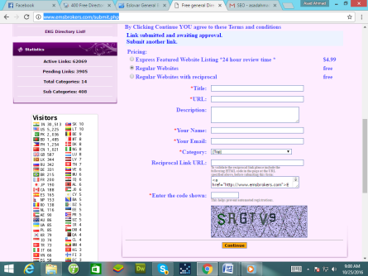 | 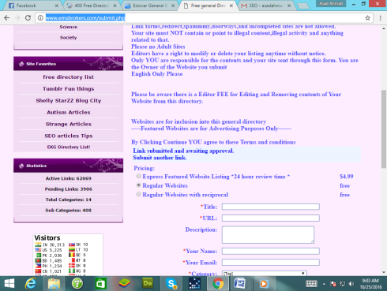
2 | http://www.eslovar.com/submit.php?c=1&LINK_TYPE=1  http://www.eslovar.com/submit.php?c=1&LINK_TYPE=1 | 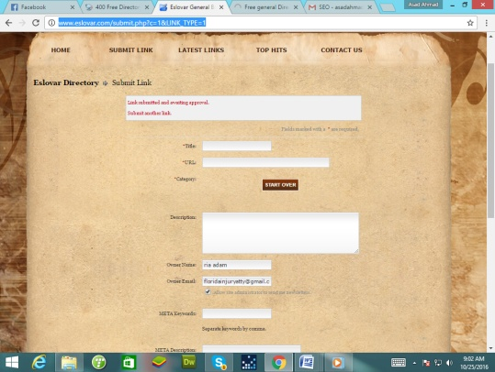 | 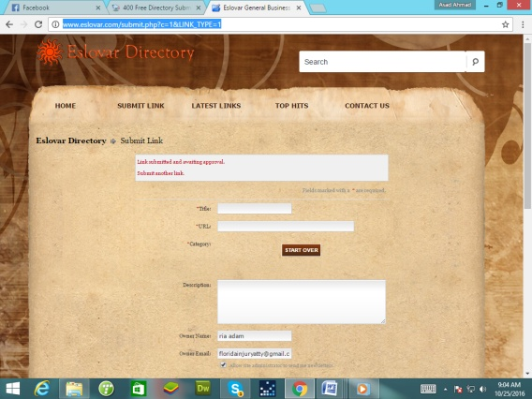
3 | http://www.europeannavigator.eu/submit.php  http://www.europeannavigator.eu/submit.php | 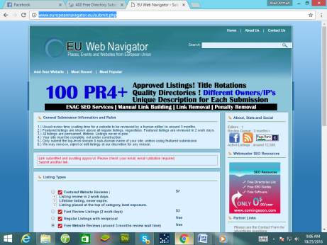 | 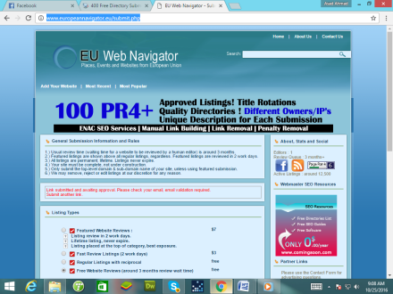
4 | http://www.fearinc.org/submit.php  http://www.fearinc.org/submit.php | 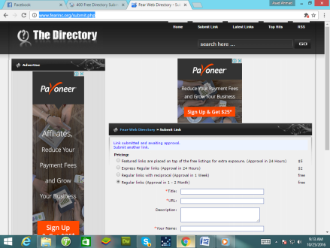 | 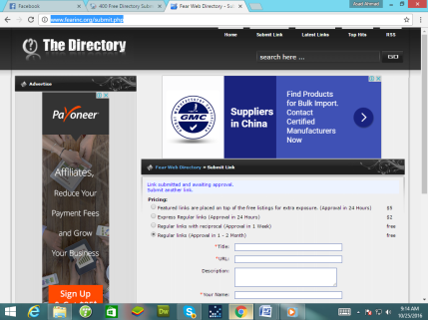
5 | http://www.field-by.com/submit.php  http://www.field-by.com/submit.php | 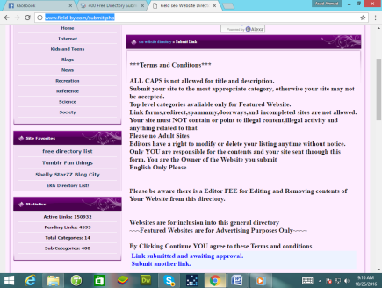 | 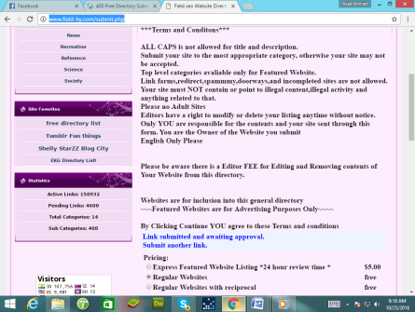
6 | http://www.fileindex.net/submit.php  http://www.fileindex.net/submit.php | 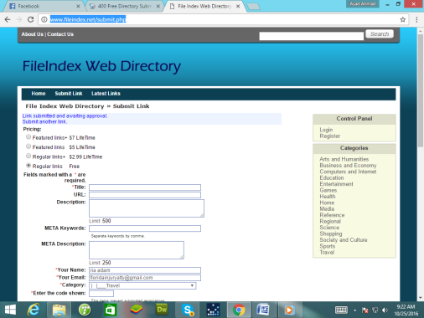 | 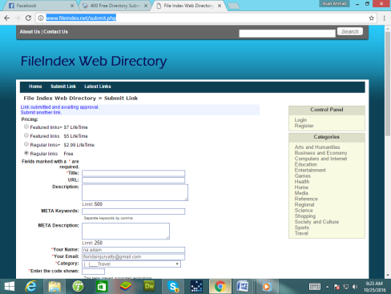
7 | http://www.fivestarsautopawn.com/submit-url  http://www.fivestarsautopawn.com/submit-url | 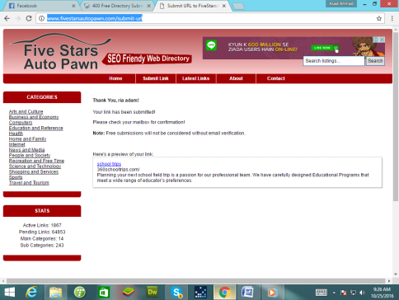 | 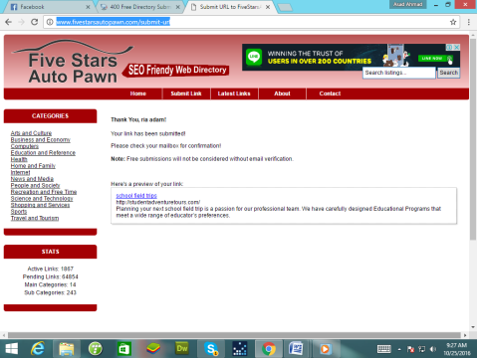
8 | http://www.fivestarscenter.com/submit-url  http://www.fivestarscenter.com/submit-url | 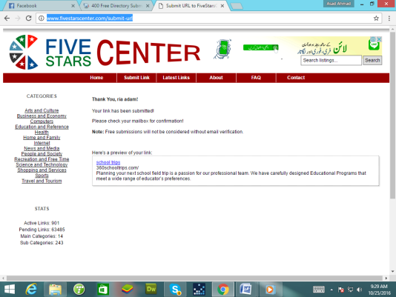 | 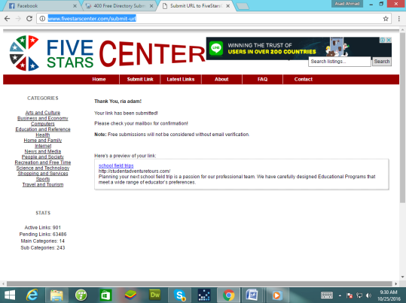
9 | http://www.freeinternetwebdirectory.com/submit.php  http://www.freeinternetwebdirectory.com/submit.php | 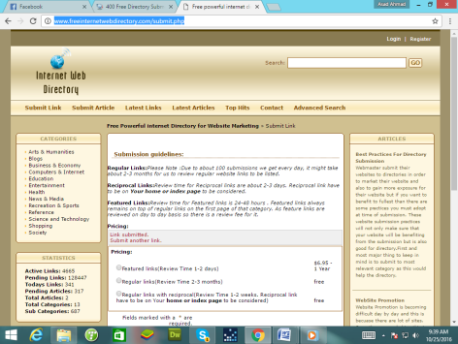 | 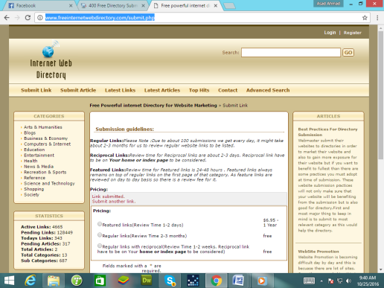
10 | http://www.freeprwebdirectory.com/submit.php  http://www.freeprwebdirectory.com/submit.php | 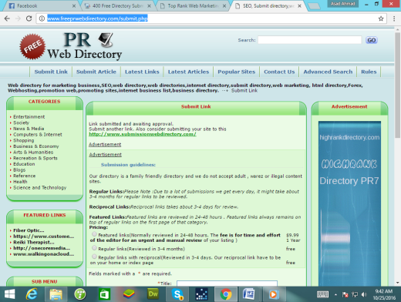 | 